**Machine Learning (Assignment #2)**

Name : Mounika Kandula.

700747570

GitHub Link: https://github.com/MounikaKandula/MachineLearningAssignment2

Video Link: https://drive.google.com/file/d/1N82qYsFcNm45L8K9E-aZNt_0M44OCwjU/view?usp=sharing

**Question 1 :** Use a python code to display the following star pattern using the for loop .

**Program 1:**

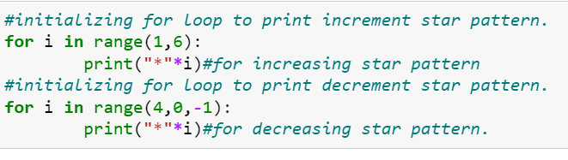

**Output:**

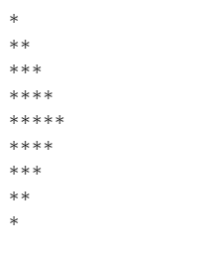

**Explanation :**

We have used for loop to print star pattern. The first for loop in the code prints the increasing pattern in the star up to 5 lines whereas the second for loop prints the decreasing pattern in the star.

**Question 2 :**

Use looping to output the elements from a provided list present at odd indexes.

my_list = [10, 20, 30, 40, 50, 60, 70, 80, 90, 100]

**Program 2 :**

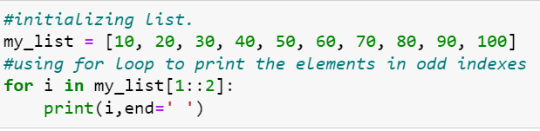

**Output :**



**Explanation 2:**

In order to print the values in the odd indexes we have used slicing as the range for the for loop. So mylist[1::2] means values from the index 1,it starts. And increments with the value of 2.Which means the odd places are printed.

**Question 3:**

Write a code that appends the type of elements from a given list.

Input

x = [23, ‘Python’, 23.98]

Expected output :

[23, 'Python', 23.98]

[<class ‘int’>,<class ‘str’>,<class ‘float’>]

**Program 3:**

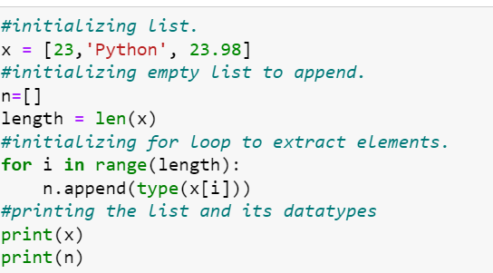

**Output:**

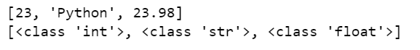

**Explanation 3:**

To print the data type of each element in the list,we have used type. And for each type of value we have appended it to new list called n. then printed the output as shown in the above figure.

**Question 4** :

Write a function that takes a list and returns a new list with unique items of the first list.

Sample List: [1,2,3,3,3,3,4,5]

Unique List: [1, 2, 3, 4, 5]

**Program 4:**

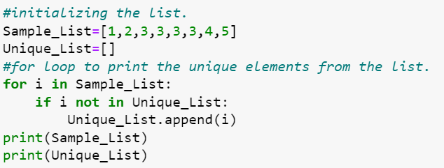

**Output:**



**Explanation :**

Given a sample list with values for finding the unique values in the list we have created a for loop which will iterate each value in the list so in for each iteration we will verify if it is in the unique list if not, we will append the value in the list.

**Question 5:**

Write a function that accepts a string and calculate the number of upper-case letters and lower-case letters.

Input String: 'The quick Brow Fox'

Expected Output: No. of Upper-case characters: 3

No. of Lower-case Characters: 12.

**Program :**

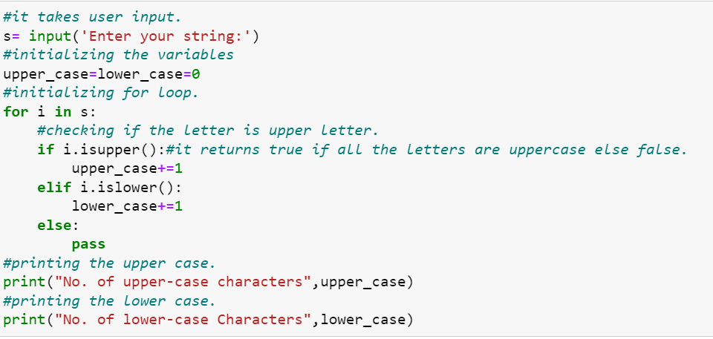

**Output:**

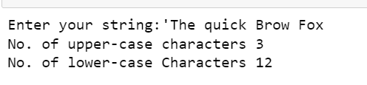

**Explanation :**

In this program we need to calculate the upper and lower_case in the string.For that,Firstly we have asked the user to enter the string.Then the isupper() checks the uppercase letters in the string,if the string is present it returns true else it returns false.islower() checks the lowercase letters in the string.Then the count of upper and lower case is printed.